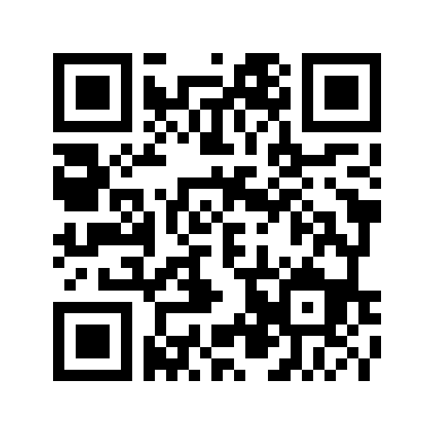
Marwa Farrag (Marwa Mahrous Mohammed Farrag)

    - Assistant lecturer at pharmacognosy department, Assuit university, Egypt.
    - PhD student at Department of BioMolecular Sciences, University of Mississippi, USA.
    - Phone: (662) 202-4278 in USA, (+2) 01015553942 in Egypt.
    - Email: Marwa.mhros@pharm.aun.edu.eg, mmmoham1@go.olemiss.edu.
    - LinkedIn:https://www.linkedin.com/in/marwa-farrag-322575159?lipi=urn%3Ali%3Apage%3Ad_flagship3_profile_view_base_contact_details%3Beth8Hhw4TQSx%2FQtcJ7h3Wg%3D%3D.
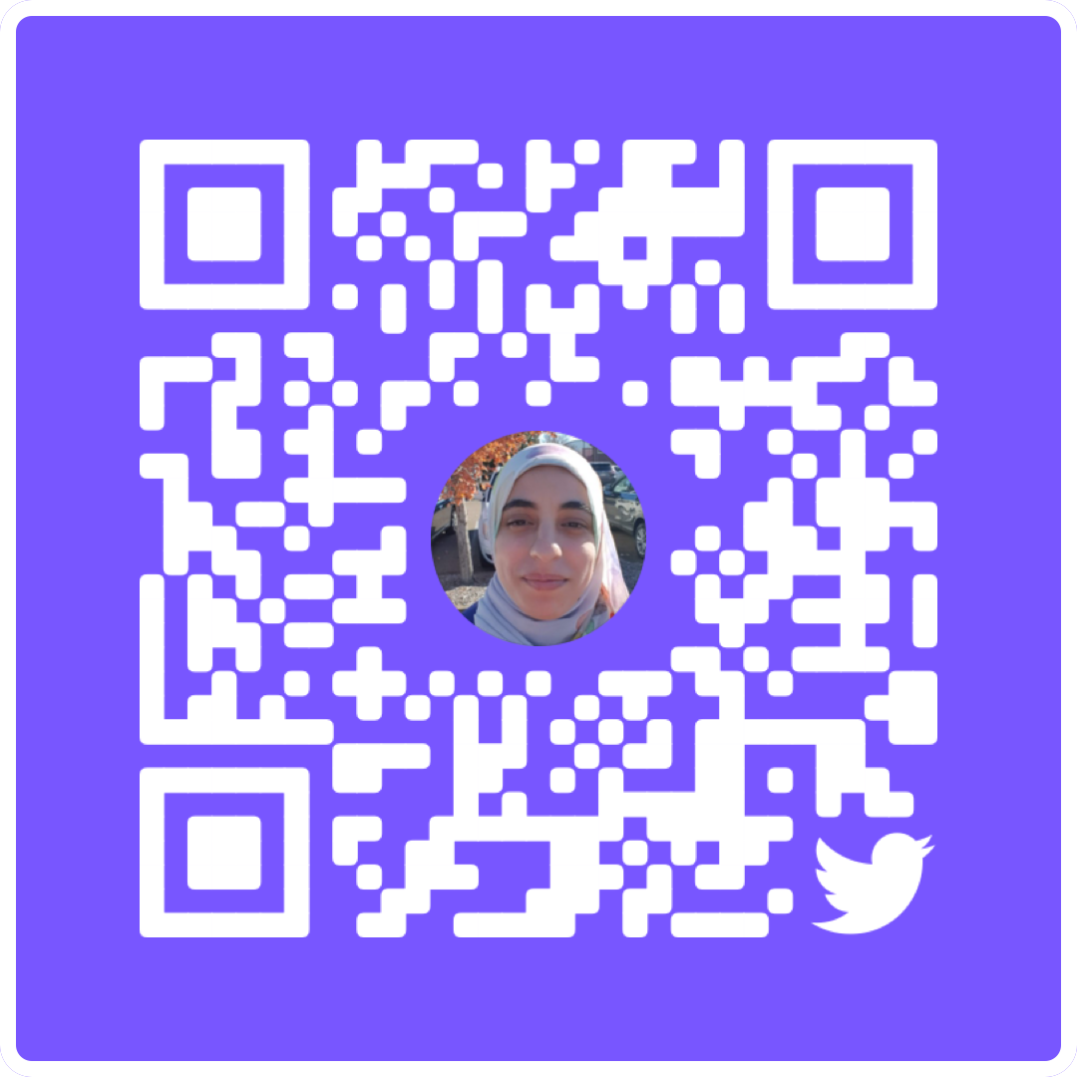
    - Twitter: @MarwaMMFarrag
    - Researchgate: https://www.researchgate.net/profile/Marwa-Farrag-2
    - Orchid ID: https://orcid.org/0000-0001-7104-3815

Research Interests:
- My research is focused on finding biologically active natural products by exploring extracts from a variety of sources, mainly plants and marine organisms, then investigating their chemical and therapeutic properties.
- Glycobiology especifically sulfated glycans of marine organisms and their antiviral and anticoagulant properties.
Education:
Expected 2025 Ph.D. in BioMolecular Sciences Department of BioMolecular Sciences, Divisions of Environmental Toxicology & Pharmacognosy, University of Mississippi, oxford, MS, USA.
2017 M.A. in Pharmaceutical Sciences (Pharmacognosy/ Natural product chemistry), pharmacognosy Department, Faculty of Pharmacy, Assiut University, Assiut (Egypt).
Thesis title: A Pharmacognostical study of Faidherbia albida (Del.) A. Chev. (Acacia albida (Del.)) F: Fabaceae cultivated in Egypt.
2012 B.S. in pharmaceutical sciences: Faculty of Pharmacy, Assiut University, Assiut (Egypt). Grade: Excellent with honor.

Professional Appointments:
2021- present Graduate Research Assistant
Department of BioMolecular Sciences, Pharmacognosy Division, University of Mississippi, oxford, MS, USA.
2017-present Assistant lecturer
Pharmacognosy Department, Faculty of Pharmacy, Assiut University, Assiut (Egypt).
2012-2017 Teaching Assistant
Pharmacognosy Department, Faculty of Pharmacy, Assiut University, Assiut (Egypt).
Publications:
- Rohini Dwivedi, Poonam Sharma, Marwa Farrag, Seon Beom Kim, Lauren A. Fassero, Ritesh Tandon and Vitor H. Pomin, (2022) Inhibition of SARS-CoV-2 Wild-Type (Wuhan-Hu-1) and Delta (B.1.617.2) Strains by Marine Sulfated Glycans. Glycobiology. DOI: 10.1093/glycob/cwac042
- RA Abdel-Emam, Marwa M. Mohammed (Marwa Farrag(, Ahmed A. Ali, Ezz-eldin K. Desoky and Lourin G. Gobraeil, (2021) Anti-hyperglycemic activity of total ethanolic fruit extract of Faidherbia Albida on nicotinamide-streptozotocin-induced diabetic mice. Bulletin of Pharmaceutical Sciences. Assiut 44 (1), 41-48.
- Marwa M. Mohammed (Marwa Farrag(, Ahmed A. Ali, Ezz-eldin K. Desoky and Lourin G. Gobraeil, (2018) Compounds isolation and in vitro antioxidant activity evaluation of Faidherbia albida (Del.) A. Chev. leaves ethanolic extract, Journal of Pharmacognosy and Phytochemistry. 7(2): 471-475.
- Marwa M. Mohammed (Marwa Farrag(, Ahmed A. Ali, Ezz-eldin K. Desoky and Lourin G. Gobraeil,(2018) Compounds isolation and antioxidant activity of Faidherbia albida fruit extract, International Journal of Chemistry Studies, 2(2); 35-40.
- Marwa M. Mohammed (Marwa Farrag(, Ahmed A. Ali, Ezz-eldin K. Desoky and Lourin G. Gobraiel, (2018) Macro- and micromorphology of the leaf, stem, stem bark and fruit of Faidherbia albida (Del.) A. Chev. cultivated in Egypt, Bull. Pharm. Sci. Assiut University, Vol. 41, 2018, 1-29.
Academic and Research skills:
Teaching experience: 2012-2020
- teaching practical courses of Pharmacognosy, Phytochemistry, Quality control of herbal drugs and alternative Medicine to undergraduate Pharmacy students.

Research experience:
- Extraction, Isolation, and purification of natural compounds using different chromatographic techniques, then, Identification of compounds using different spectroscopic techniques.
- Sulfated Glycans isolation and depolymerization from marine organisms.
- Gel electrophoresis.
- Identification of plant tissues using a microscope.
- APTT assay.
- anticoagulant serpin inhibition assay
Training programs and courses:
- December 2021: virtual Computational Glycoscience Workshop titled “computational modeling of Glycan/GAG structure and their interaction with proteins” conducted by: Computational Chemistry and Bioinformatics Research Core (CCBRC), Glycoscience Centre of Research Excellence (GlyCORE), University of Mississippi.
- Novamber 2021: Workshop titled “introduction to proteomics sample preparation”, Organized by-Analytical & Biophysical Chemistry Core (Core ABC) GlyCORE, University of Mississippi
- December 2012: Workshop titled “Essential Research Skills”, Assiut University.
- January 2013: training program titled "use of technology in teaching", FLCD center, Assiut University.
- August 2017: training program titled "Quality standards in teaching 1", FLCD center, Assiut University.
- August 2017: training program titled "conferences organization", FLCD center, Assiut University.
- August 2017: training program titled "Financial aspects in university environment", FLCD center, Assiut University.
- August 2017: training program titled "Analytical and creative thinking", FLCD center, Assiut University.

